Lesson Name | Family Tree
Topic: | Students will participate in research their personal history by way of creating a family tree
Objectives:  Essential Understandings | Students will be able to research their ancestry  Students will be able to use their family tree in their introductions
Internal/ External Assets addressed | Internal:  Commitment to learning-students are learning about their own history  Positive values-students learn about themselves and value their own history  Positive identity  External:  Support-students feel the support of their extended tribal community  Empowerment-knowing your history is important your identity and how you see the world
Standards or language proficiency descriptors: | Productive language standards: Produce learned words and phrases and repeat the words and phrases to describe family. Use the graphic organizer to organize information about your history.  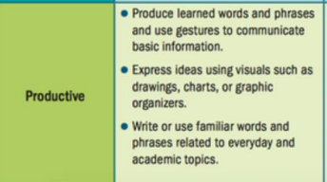
World readiness standards | 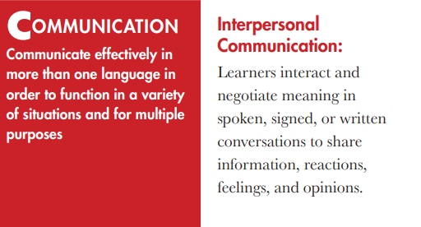  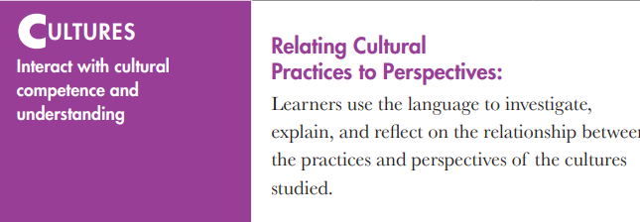  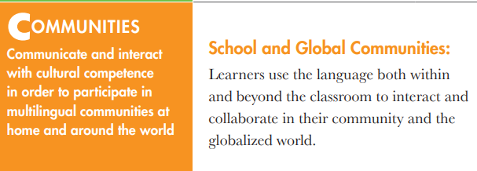
Words of the week | Family: _______________________________________________________________  Mother: _____________________________________________________________  Father: ______________________________________________________________  Grandfather/Grandmother:______________________________________________  Me or My: ____________________________________________________________  The Name of your tribe in your language:_____________________________(ie Dine instead of Navajo)
STEPS to success | - Research your background and relatives. You may need help from a trusted adult.  - Using the information, use those language words in your introduction  - Practice your introduction
Guiding Questions: | Did you learn anything new about your history?  Why do you think it’s important to know your background and personal history?  What feelings came up as you were doing research?
Signs of cultural growth/ Measurable student outcomes: | Students will research their history. This has the potential to be difficult for some students and bring up emotions that they may need help being guided through. If they can speak to the importance of this exercise and describe what feelings they have on a micro/personal level or a macro/cultural level, then that is a sign of cultural growth
Traditional Knowledge or Teachings | Students will understand that it is something to be proud of to know their family tree. Our people have been fighting erasure for hundreds of years, so it remains critical that we know we come from and can speak to our tribal connectedness and citizenship.
SEL connections | 