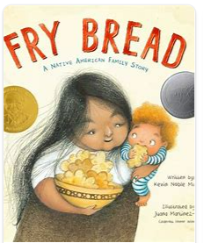**Welcome to 2022 Frybread Night!** 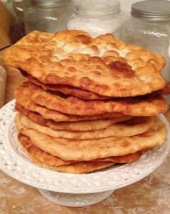

*Students and families will be able to make their own frybread with the help of a virtual cooking lesson with Chef Joseph Newman. The making of frybread began in 1864 when the Dine people began making it with the commodities given to them by the US government. Those commodities were flour, sugar and salt. When the Dine were relocated and could no longer live on land that supported their traditional foods, they made frybread out of necessity. It is now considered a “Native” food, but the history is more complex than that.*

Word Exploration for frybread night:

Look up these words for: flour, salt, sugar, water, oil, hand (this will make sense as Joseph guides us in the lesson)

Label those items at home and as you are using it in the lesson try to say the word as you make your frybread.

Example in our house:

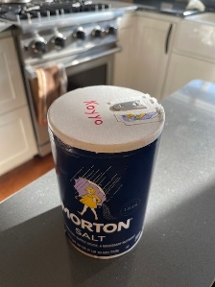

Need more of a challenge?

Write your numbers for each step as you go, write the recipe down.

Step ______________: Mix the _______________ and the _____________ in your ____________.

Step ______________:Mix the ___________ into your mixture of __________ and _____________.

Step ______________:______________________________________________________________

Step ______________:______________________________________________________________

Phrases:

I can cook. I can make delicious food. Thank you for this delicious food.

Resources: if you need resources please reach out to ikearnsus@gmail.com . We’re keeping a data base of resources and guide you to find language help for your specific tribe.